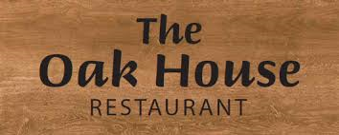
FATHERS DAY
21st June 2026
3 COURSE MENU
£32 per person

STARTERS
Butternut Squash & Red Pepper Soup, crusty bread (v) (gfo)

Sweet Chilli Chicken, garlic mayo
Ham Hock & Pea Terrine, apple chutney & toasted ciabatta (gfo)
Spicy Cauliflower Bites, mango salsa (ve)

Prawn Cocktail, marie rose sauce (gfo)

MAINS
Main courses served with Homemade Yorkshire Pudding (excl Salmon)
Roast & Mash Potatoes and Seasonal Vegetables for the table to share

Dry Aged Topside of Beef (gfo)
Roast Loin of Pork & Crackling (gfo)
Churchill Roast Chicken & Stuffing (gfo)
Vegetarian Wellington (v)
Steak & Ale Pie
Terriyaki Salmon (gf)

DESSERTS
Biscoff & Toffee Cheesecake (v)
Chocolate Brownie, vanilla ice cream (v)
Mango Sorbet (ve) (gf)
Sticky Toffee Pudding, crème anglais (v)
CORKAGE - £2.00 per person to bring your own wine but we are also now fully licensed

CHILDRENS MEAL - £12 (under 12s)
Soup or Garlic Bread / Sunday Roast / Ice Cream

Vegetarian (v), Vegetarian option is available (vo) Vegan (ve), Vegan option is available (veo) Gluten Free (gf), Gluten Free Option is available (gfo) –NB some dishes can be adapted to be gluten or dairy free, please inform your server of allergies/dietary requirements when ordering and ask to see our allergen information. We regret we cannot guarantee our food products are completely nut free.

